CSC 256-02 Fall 2020 Assignment 1

1. (20 points) Play the game <https://studio.code.org/projects/applab/iukLbcDnzqgoxuu810unLw> The score should be higher than “1000" (20 points) . Insert your screenshot here.  
     
   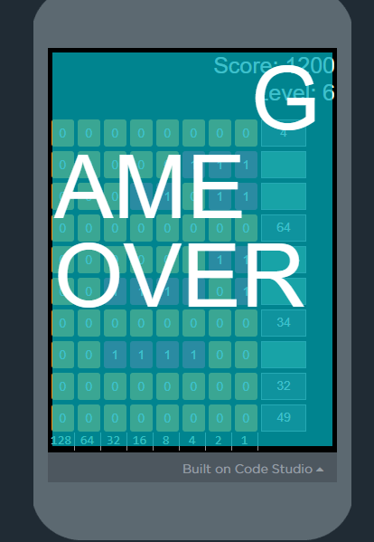
2. (40 points)For **unsigned** binary number and **unsigned** hexadecimal number, please calculate from i) to iv). (Show intermediate steps on **the carry and borrowing as we shown in the class clearly**. You **do not** receive any credit for just writing down the answer). You can insert your handwriting screenshot in the document.
3. (0000 1010)2 + (0001 1111)2
4. (0000 1011)2 + (0011 1110)2
5. 0x ABC111 + 0x 111DEF
6. 0x 4A6 - 0x1B3
7. 0x 1DF000 - 0x 111DEF

SCREENSHOT OF HOMEWORKIS BELOW

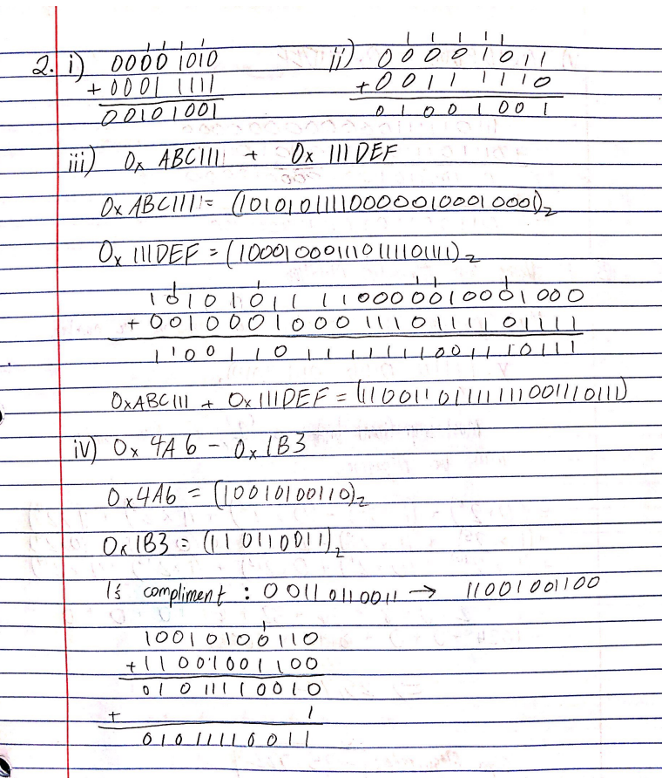

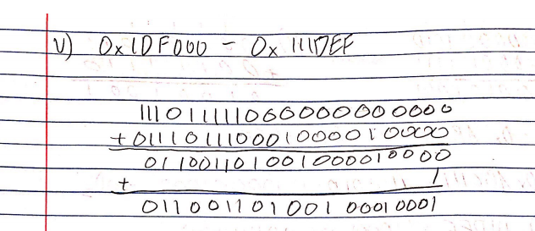

1. (40 points) You are given a 16-bit binary integer X= (1110 0100 0111 1010)2

Convert X to decimal if

1. X is unsigned
2. X is in sign-magnitude notation
3. X is in one’s complement notation
4. X is in two’s complement notation

